PRACTICAL - 1

Aim: Create Google form For Student Registration to attend a Janmashtami Festival. (With File Upload).

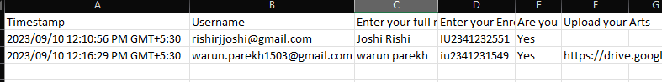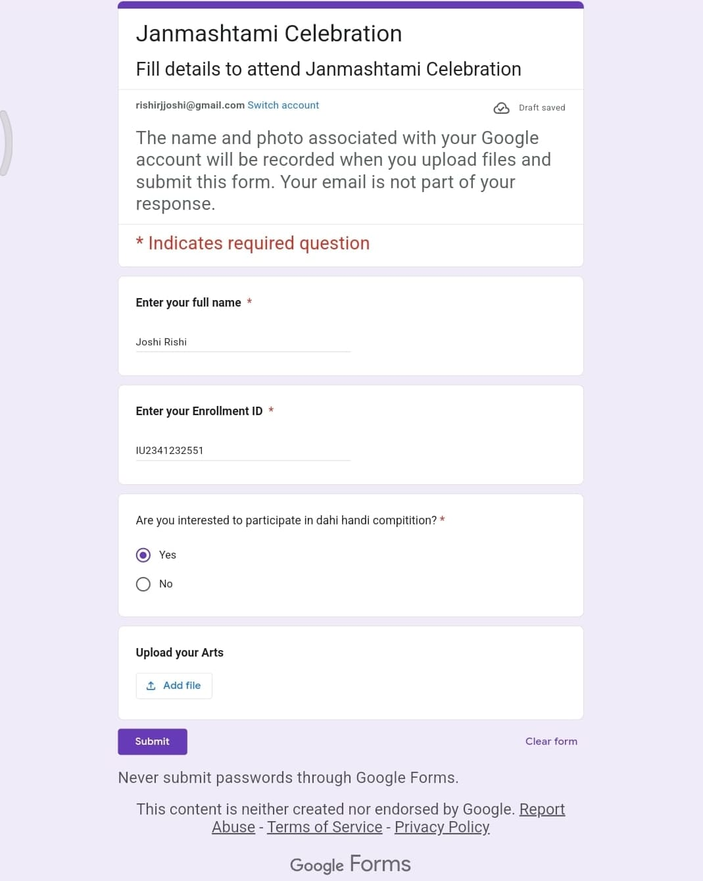Solution: [Janmashtami Celebration](https://forms.gle/MjNGTHSJe2pkCbU68)

Signature of Faculty: Date: